Plato, Aristotle, and the Problem of Universals
Christopher L. Holland
February 13, 2025
Before we look at epistemology in contemporary philosophy we will take a quick look at a related question in metaphysics.

1. Background (Some Quick Ancient Metaphysics)

1.1 Plato and Platonic Realism
- Theory of the Forms (Eternal Ideas)
  - How can there be many of one kind of thing?
    - What do red things have in common? Their form: Redness.
    - What do trees have in common? Their form: Treeness.
    - What do human beings have in common? Their form: Humanness.
    - What do all good things have in common? Their form: Goodness.
  - Plato’s answer: Particular things (this red thing, this tree, etc.) “participate in” the Forms (redness, treeness, etc.)
    - Particular things change
    - Forms do not. They are
      - Eternal
      - Unchanging
  - Neoplatonic Interpretation: The Forms are the most real things; particular things are less real than the Forms
  - Alternative Interpretation: Forms and particulars are equally real. The Forms are good objects of knowledge (because they do not change). Particulars are bad objects of knowledge (because they can change).
- Innate Ideas: Knowing as Remembering
  - Plato held that learning is really a recollecting of what we learned in a previous existence.
  - Later Platonists suggest that we were created with these ideas.
- Implications
  - Knowledge is only about things that do not change
  - Truth does not change
  - But, mere belief/opinion is
    - about changing things
    - about appearances

1.2 Aristotle and Aristotelian Realism
- Rejected Plato’s Theory of the Forms
- Forms are merely the way that particular things exist
- Hylomorphism
  - Particular things are made up of matter and form
  - matter gives a thing “potentiality”
  - form gives a thing “actuality”
  - Example:
    - the same wood can be a tree and later a chair
    - the matter (wood) is the same but the form (tree then chair) changes
- Abstraction: A process of the mind that separates form from matter

2. Scott Berman’s Flow Chart for Universals
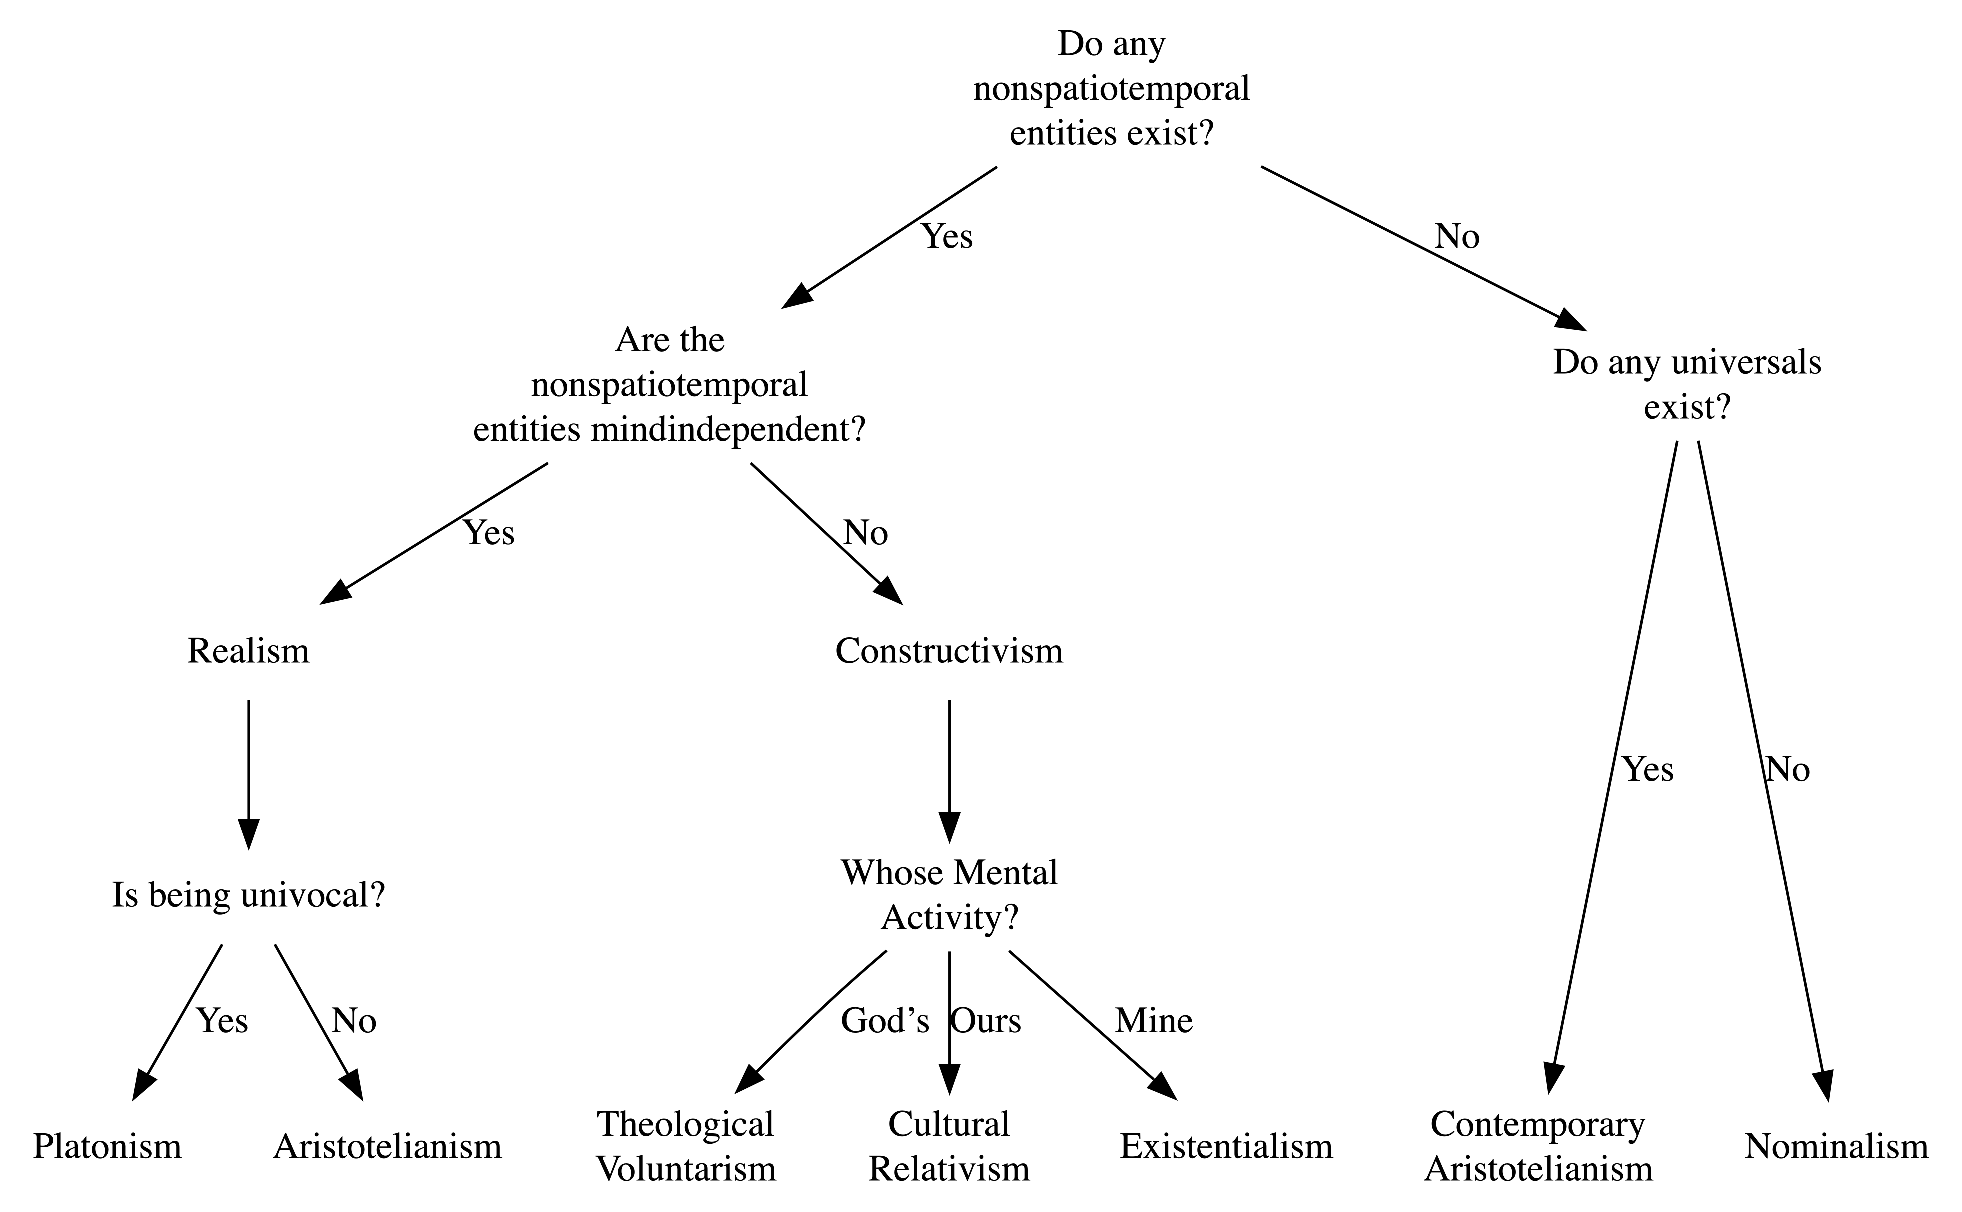

Figure 1: Flow chart based on the appendix to Scott Berman, Platonism and the Objects of Science (London: Bloomsbury Academic, 2020).

