The Problem of Perception
Christopher L. Holland
February 20, 2025

1. The Problem of Perception

1.1 The Problem of Perception
Consider the difference between appearance and reality
- Parallel railroad tracks appear to converge in the distance
- The volume and pitch of a siren changes as it passes by
- A straight stick appears bent when half of it is placed in water
- What would happen if you placed one hand over a warm stove and the other in a bucket of ice, then place both in a bowl of lukewarm water?

1.2 Direct Realism
- The immediate object of perception is a physical object existing independently of our awareness of it.
- Supported by common sense
But . . .
Naive realism [direct realism] leads to physics, and physics, if true, shows that naive realism is false. Therefore, naive realism, if true is false; therefore it is false.
— Bertrand Russell

2. Representationalism, Idealism, and Phenomenalism
The immediate object of perception is a perceptual intermediary, an object that cannot exist apart from our awareness of it.
Perceptual intermediaries
- sense data
- sense impressions
- ideas
- percepts

2.1 Representationalism
Physical objects give rise to sense data that we perceive, so we only have mediate knowledge of the external world.
Locke’s Causal Theory of Perception
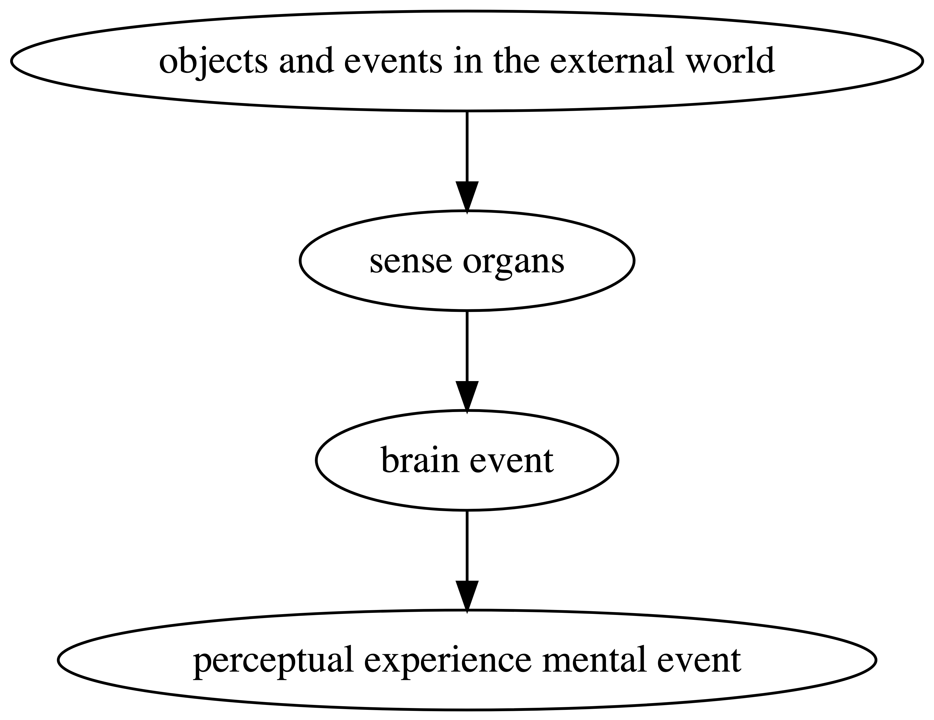

Figure 1: Locke’s Causal Theory of Perception
Primary Qualities
Qualities of an object that exist independent of the existence of a perceiver.

Secondary Qualities
Qualities of an object that are perceiver dependent. They are powers, potentialities, or dispositions that reside in a physical object.

2.1.1 Primary Qualities
- Inseparable from their object
- Truly represent their object
- Locke’s list
  - Solidity
  - Extension
  - Figure
  - Movement (and rest)
  - Number

2.1.2 Secondary Qualities
Locke’s list
- Color
- Sounds
- Smells
- Taste
- Touch
- Sensations

2.2 Objections
- How can we justify any knowledge about the external world if we are never directly aware of anything but our ideas?
- Permanent-Picture-Gallery Objection
  - Imagine that you’re looking at a photo of a landscape and want to check its accuracy.
  - Normally you would compare the photo with the scene itself.
  - But, if representationalism is true, this is impossible. You only have access to more photos.
Berkeley’s Criticisms
According to Berkeley, Locke’s representationalism:
- took away the beauty of the physical world
- failed to explain mental events (the mind/body problem)
- led to absurd consequences
  - Assume an object has primary and secondary qualities. But we can’t perceive the primary qualities without perceiving its secondary qualities, so neither primary nor secondary qualities exist independently of our sense impressions.
  - How can a mental event represent a physical one?
(Similar to the permanent-picture-gallery objection)
  - Representationalism leads to a rejection of God and to materialism (the doctrine that matter is all there is)

3. Idealism and Phenomenalism

3.1 Idealism
Physical objects are simply constructions of sense data; they do not exist independently of sense impressions.
Berkeley’s Idealism
Berkeley’s solution to the problem of perception was to deny that matter exists.
- All reality is immaterial: either minds or mental events
- esse est percipi: to be is to be perceived
[A]ll the furniture of the earth … have not any subsistence without a mind … their being is to be perceived or known, … consequently, so long as they are not actually perceived by me or do not exist in my mind or that of any other created spirit, they must either have no existence at all or else subsist in the mind of some external spirit … it being perfectly unintelligible … to attribute to any single part of them an existence independent of a spirit.
— George Berkeley

3.2 Phenomenalism
- Similar to idealism, except physical objects can exist unperceived since there is the continued possibility of experience.
- Material objects are nothing but “permanent possibilities of sensation” (J.S. Mill).
- Scientific discovery is not literal but instrumental. It supplies us with useful fictions that help us predict experience.

3.3 Objections to Idealism and Phenomenalism
How can Idealism or Phenomenalism really account for …
- the difference between appearance and reality
- the permanency of material things
- causal activity (because we only perceive effects, causes are unperceived)
O’Brien, Daniel. n.d. “Perception, Objects Of.” In Internet Encyclopedia of Philosophy. Accessed February 4, 2019. https://iep.utm.edu/perc-obj/.
Pojman, Louis P. 2006. Philosophy: The Pursuit of Wisdom. 5th ed. Belmont, CA: Wadsworth.
Pojman, Louis P., and Lewis Vaughn, eds. 2017. Philosophy: The Quest for Truth. 10th ed. New York: Oxford University Press.

